**Basic Reb0rn**

**Game Design Document**

*This game design document describes the details for BASIC Reb0rn, a text adventure game ported from AppleSoft BASIC with a Haunted House theme.*

# **Contents**

Contents 2

Section 1 – Overview 3

1.1 Story 3

1.2 Genre and Theme 3

Section 2 – Gameplay 4

2.1 Goal 4

2.2 User Skills 4

2.3 Game Mechanics 5

2.3.1 Actions 5

2.3.2 Map 6

2.3.3 Objects to Collect 7

2.3.4 Other Game Objects 7

2.6 Screen Flow 8

2.7 Traps 9

2.7.1 Bats 9

2.7.2 Ghosts 9

2.7.3 Marsh 9

2.8 Game Walkthrough 10

Section 3 – Art Style 11

Section 4 – Technical Description 11

Section 5 – Possible Additional Features 11

# **Section 1 – Overview**

## **1.1 Story**

*A weird old house stands on the edge of a sheer cliff, its strange twisted turrets looming out of an always gloomy sky. No walls seem straight, no corner a right-angle. Not surprisingly no one lives there, no human that is.*

*People say the richest man in the world spent his last days there, but no one has ever found his body.*

*Our adventurer stands on the path, the house looming over them and strange noises coming from within…*

## **1.2 Genre and Theme**

*This game is a text adventure all about mystery and fantasy, the player is constantly trying to figure out a way to leave as well as to find all the objects of the house. The magical and supernatural aspects are hidden throughout the map for the player to discover.*

# **Section 2 – Gameplay**

## **2.1 Goal**

*The overall goal of the original game is for the player to collect all 18 items and escape the haunted house. The game documentation sets up special “treasure” items but does nothing with them. So, in this version of the game, the player’s goal is to collect all 8 “treasures”, when done they will be given a message to say they have completed the game.*

*The player should go back to the front door in order to see their score, this will then take them to the Game Over screen.*

*These “treasures” are shown in bold in section 2.3.3.*

*The score will be increased by the number of extra items the player has collected, to get a maximum score of 89.*

## **2.2 User Skills**

1. *Typing*
2. *Memory*
3. *Puzzle Solving*
4. *Manging Resources*
5. *Strategy*

## **2.3 Game Mechanics**

### **2.3.1 Actions**

*The following table of inputs shows what words the player will be able to type to move around and interact with the house. Some words have a specific object (defined in the JSON file), others can refer to any object, and some require no second word / object.*

*I have used the verbs from the original game, but have changed the “CARRYING?” action to “INVENTORY” instead.*

|  |  |  |  |
| --- | --- | --- | --- |
| ***Verb Number*** | ***Verb*** | ***Applies To*** | ***Action*** |
| *0* | *HELP* | *-* | *Lists all verbs the computer knows* |
| *1* | *INVENTORY* | *-* | *Lists all the objects the player is carrying* |
| *2* | *N* | *-* | *Move North* |
| *3* | *E* | *-* | *Move Est* |
| *4* | *S* | *-* | *Move South* |
| *5* | *W* | *-* | *Move West* |
| *6* | *GET* | *OBJECTS* | *Pick up an object (object must be in location)* |
| *7* | *TAKE* | *OBJECTS* | *Pick up an object (object must be in location)* |
| *8* | *EXAMINE* | *ANYTHING* | *Reveals any concealed object* |
| *9* | *LEAVE* | *ANY WORDS* | *Leave object behind (must have object)* |
| *10* | *SCORE* | *-* | *Prints out the score* |
| *11* | *OPEN* | *DOOR* | *Opens door, must have key* |
| *12* | *OPEN* | *DRAWER* | *Opens desk in study* |
| *13* | *READ* | *BOOKS* | *Examines books in library* |
| *14* | *READ* | *SPELLS* | *Reads spell book (“XZANFAR”)* |
| *15* | *SAY* | *ANY WORDS* | *Says words typed “out loud” (e.g. casts spells)* |
| *16* | *DIG* | *-* | *Makes a hole (must have shovel and be in cellar)* |
| *17* | *SWING* | *AXE* | *Breaks down false wall (must have axe and be in study)* |
| *18* | *CLIMB* | *TREE* | *Climb the blasted tree* |
| *19* | *SPRAY* | *AERSOL* | *Removes bats from rear tower (need aerosol)* |
| *20* | *USE* | *VACUUM* | *Sucks up ghosts (need vacuum and batteries)* |
| *21* | *LIGHT* | *CANDLE* | *Turns light on (must have candle, matches and candlestick)* |
| *22* | *UNLIGHT* | *CANDLE* | *Turns light off (must be carrying lighted candle)* |

### **2.3.2 Map**

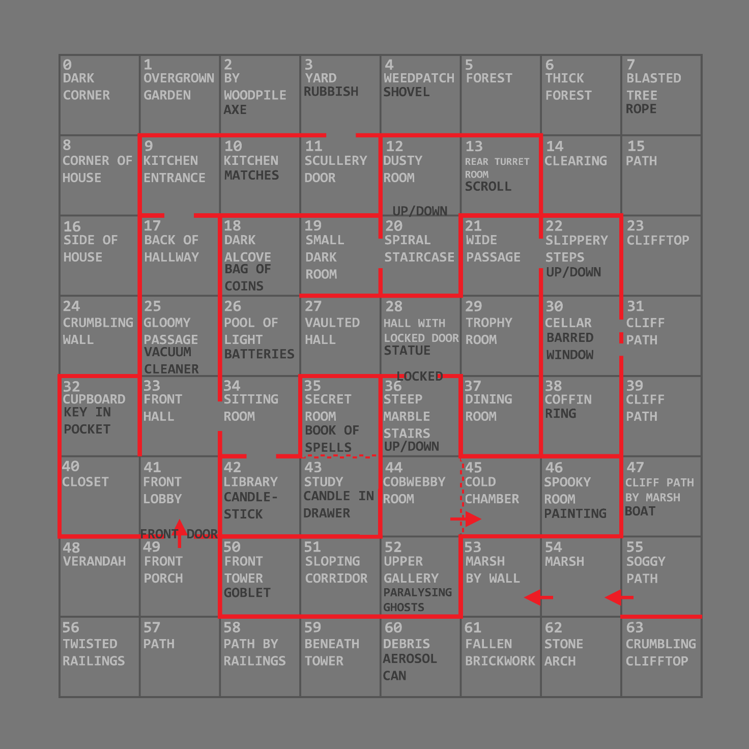

### **2.3.3 Objects to Collect**

|  |  |  |  |
| --- | --- | --- | --- |
| ***Object Number*** | ***Object*** | ***Location*** | ***Use*** |
| ***1*** | ***Painting*** | ***Spooky Room*** | ***-*** |
| ***2*** | ***Ring*** | ***Deep Cellar*** | ***-*** |
| ***3*** | ***Spellbook*** | ***Secret Room*** | ***Breaks magical barrier*** |
| *4* | *Rope* | *Blasted Tree* | *Climb up and down* |
| ***5*** | ***Scroll*** | ***Rear Turret Room*** | ***-*** |
| ***6*** | ***Coins*** | ***Dark Alcove*** | ***-*** |
| ***7*** | ***Statue*** | ***Hall with Locked Door*** | ***-*** |
| ***8*** | ***Candlestick*** | ***Library*** | ***Hold candle*** |
| *9* | *Matches* | *Kitchen* | *Light candle* |
| *10* | *Vacuum* | *Gloomy Passage* | *Suck up Ghosts* |
| *11* | *Batteries* | *Pool of Light* | *For Vacuum* |
| *12* | *Shovel* | *Weed Patch* | *Dig around bars* |
| *13* | *Axe* | *By Woodpile* | *Destroy false wall* |
| ***14*** | ***Goblet*** | ***Front Tower*** | ***-*** |
| *15* | *Boat* | *Cliff Path by Marsh* | *Get across Marsh* |
| *16* | *Aerosol* | *Debris* | *Flee Bats* |
| *17* | *Candle* | *Study (Drawer)* | *Light source* |
| *18* | *Key* | *Cupboard (Coat Pocket)* | *Unlock door* |

### **2.3.4 Other Game Objects**

|  |  |  |  |
| --- | --- | --- | --- |
| ***Object Number*** | ***Object*** | ***Location*** | ***Use*** |
| *19* | *Door* | *-* | *Opens* |
| *20* | *Drawer* | *Study* | *-* |
| *21* | *Desk* | *Study* | *-* |
| *22* | *Coat* | *Cupboard* | *-* |
| *23* | *Bats* | *Rear Turret Room* | *Scares the player* |
| *24* | *Ghosts* | *Upper Gallery* | *Paralyses the player* |
| *25* | *Books* | *Library* | *-* |
| *26* | *Tree* | *Blasted Tree* | *-* |

## **2.6 Screen Flow**

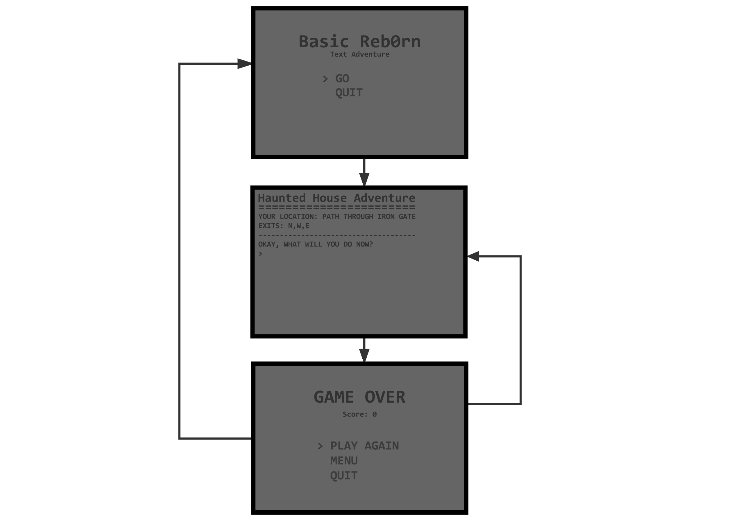

## **2.7 Traps**

### **2.7.1 Bats**

*The Bats are located in the Rear Turret Room of the game, they protect the scroll from being taken, and can be scattered from the room using the Aerosol. While in the presence of the Bats the player cannot do anything, making it impossible to collect the scroll without first dealing with the Bats. In my version for the game the player will be allowed to leave the room, in order to keep gameplay going.*

### **2.7.2 Ghosts**

*The Ghosts act in a similar way to the Bats, by paralysing the player. While in the Upper Gallery with the Ghosts the player cannot do anything due to fear. The Ghosts can be removed by using the Vacuum Cleaner to suck them up. In my version, the player will be able to leave the room the way they came in, making the Ghosts act as a blockage, disabling passage through the Upper Gallery until they are removed.*

### **2.7.3 Marsh**

*The Marsh is a room outside of the House which can only be accessed by boat and can only be traversed one way – from North to South.*

*There is a bug in the original game with carrying the boat; when you get across the marsh the game just says to you “YOU CANNOT CARRY A BOAT!” without any explanation. I will tell the player that the boat is stuck, and they must leave it, when they exit the marsh.*

*Also, in the original game, you cannot enter the front door again once you have been through it, this leaves the player trapped if they do not collect the aerosol before entering the house and is frustrating. So, I will allow the player to enter the house from the front door, but not exit until they have collected all the treasures.*

## **2.8 Game Walkthrough**

1. *Collect the AEROSOL, east from the starting position.*
2. *Go back to the start and go into the house.*
3. *Go west and collect the KEY from in the COAT in the cupboard.*
4. *Go back to the main hallway and head north and out the back of the house, collecting VACUUM and MATCHES along the way.*
5. *When outside, collect the AXE and SHOVEL.*
6. *Head back into the house and head south to the Front Hall, then head east and south to the Library and Study.*
7. *Collect the CANDLESTICK, and CANDLE (hidden in the DRAWER).*
8. *Swing your AXE in the study to reveal the secret room and collect the SPELLBOOK from inside.*
9. *Head back out of the Library and head north to the Pool of Light, collect the BATTERIES.*
10. *Light the CANDLE.*
11. *Go north and head to the Rear Turret Room, use the AEROSOL to scatter the BATS and collect the SCROLL.*
12. *Head back to the Pool of Light and this time go east until you find the locked door.*
13. *Unlock it with the KEY.*
14. *Head south to the GHOSTS and use the VACUUM on them.*
15. *Then head west to get the GOBLET.*
16. *Head back the way you came and head east from the Cobwebby Room to collect the PAINTING.*
17. *Say the word ‘XZANFAR’ to knock down the magical barrier blocking the way in the Cold Chamber.*
18. *Head north to the locked door and head east and then north to get to the Slippery Stairs.*
19. *Go south and collect the RING then go back to the Cellar and dig the bars out with the SHOVEL.*
20. *Head east to get out of the house then head south and get into the BOAT.*
21. *Go south through the Marsh and get out when the BOAT becomes stuck.*
22. *Then head west until you reach the starting point and the game ends.*
23. *You win.*

# **Section 3 – Art Style**

*This game uses text-based gameplay and so the art style is simple and minimalist since the only thing to be shown on screen is text. The game text should be easy to read so information can be easily communicated to the player.*

# **Section 4 – Technical Description**

*The game will be developed for PC (Windows/Mac/Linux) and I will be using the ASGE Game Framework to develop C++ code.*

*More details regarding the technical description and requirements can be found in the* ***Basic Reb0rn Technical Design Document****.*

# **Section 5 – Possible Additional Features**

* *MAP verb that displays the mini map when typed. The map will show what rooms have already been discovered.*
* *Sounds*
* *Additional puzzles, rooms and traps*
* *The re-use of singular features like the ghosts, bats, axe, vacuum etc.*
* *Achievements*
* *ASCII style art to describe environments.*